# Example report of *OUKS*

This R Markdown document was provided as an example to reproduce the *OUKS* code script. Fig. 4 from [article](https://pubs.acs.org/doi/10.1021/acs.jproteome.1c00392) can be reproduced with the following code. Preliminarily download *“xcms after IPO MVI QC-XGB filter repeats annot+filtr LMM adj KEGG.csv”* and *“8 peaks.csv”* files into your working directory (for example: ("D:/OUKS/").

## Prepare environment

First, set the folder for the working directory and load the packages.

setwd("D:/OUKS/")  
  
library(data.table)

## Warning: package 'data.table' was built under R version 4.0.2

library(factoextra)

## Loading required package: ggplot2

## Registered S3 methods overwritten by 'tibble':  
## method from   
## format.tbl pillar  
## print.tbl pillar

## Welcome! Want to learn more? See two factoextra-related books at https://goo.gl/ve3WBa

library(FactoMineR)  
library(dendextend)

##   
## ---------------------  
## Welcome to dendextend version 1.13.4  
## Type citation('dendextend') for how to cite the package.  
##   
## Type browseVignettes(package = 'dendextend') for the package vignette.  
## The github page is: https://github.com/talgalili/dendextend/  
##   
## Suggestions and bug-reports can be submitted at: https://github.com/talgalili/dendextend/issues  
## Or contact: <tal.galili@gmail.com>  
##   
## To suppress this message use: suppressPackageStartupMessages(library(dendextend))  
## ---------------------

##   
## Attaching package: 'dendextend'

## The following object is masked from 'package:data.table':  
##   
## set

## The following object is masked from 'package:stats':  
##   
## cutree

library(rafalib)  
library(pROC)

## Type 'citation("pROC")' for a citation.

##   
## Attaching package: 'pROC'

## The following objects are masked from 'package:stats':  
##   
## cov, smooth, var

library(parallel)  
library(doParallel)

## Loading required package: foreach

## Warning: package 'foreach' was built under R version 4.0.3

## Loading required package: iterators

## Warning: package 'iterators' was built under R version 4.0.3

library(grid)  
library(caret)

## Loading required package: lattice

library(dplyr)

##   
## Attaching package: 'dplyr'

## The following objects are masked from 'package:data.table':  
##   
## between, first, last

## The following objects are masked from 'package:stats':  
##   
## filter, lag

## The following objects are masked from 'package:base':  
##   
## intersect, setdiff, setequal, union

library(MKinfer)

## Warning: package 'MKinfer' was built under R version 4.0.2

library(limma)  
library(ggplot2)  
library(cowplot)

##   
## ********************************************************

## Note: As of version 1.0.0, cowplot does not change the

## default ggplot2 theme anymore. To recover the previous

## behavior, execute:  
## theme_set(theme_cowplot())

## ********************************************************

library(ggsci)

## Load datasets

ds <- as.data.frame(fread(input = "8 peaks.csv", header=T))  
rownames(ds) <- ds[,1]  
ds <- ds[,-1]  
colnames(ds)[1] <-"Label"  
ds[,-1] <- sapply(ds[,-1], as.numeric)  
ds$Label <- as.factor(ds$Label)  
  
ds2 <- as.data.frame(fread(input = "xcms after IPO MVI QC-XGB filter repeats annot+filtr LMM adj KEGG.csv", header=T))  
ds2 <- ds2[-c(1:12),]  
rownames(ds2) <- ds2[,5]  
ds2 <- ds2[,-c(1,3:5)]  
ds2[,-1] <- sapply(ds2[,-1], as.numeric)  
ds2$Label <- as.factor(ds2$Label)

## Plot volcano plot

ds_log <- as.data.frame(log2(ds2[,-1]))  
ds_log <- cbind(Label = ds2[,1], ds_log)  
  
FOLD.CHANGE <- function(data) {  
 ds_log_subsets <- lapply(1:length(unique(data[,1])), function(y) filter(data[,-1], data$Label == unique(data[,1])[y]))   
 mean_r_l <- lapply(1:length(ds_log_subsets), function(y) apply(ds_log_subsets[[y]], 2, mean, na.rm = T))   
 foldchange <- mean_r_l[[1]] - mean_r_l[[2]]  
 fc_res <- as.data.frame(foldchange)  
 return(fc_res)  
}  
  
fc_res <- FOLD.CHANGE(ds_log)  
foldchange <- as.numeric(fc_res$foldchange)  
  
mdl_mtrx <- model.matrix(~Label, ds2)  
lmf <- lmFit(t(ds2[,-1]), method = "robust", design = mdl_mtrx, maxit = 1000)   
efit <- eBayes(lmf)  
tableTop <- topTable(efit, coef = 2, adjust = "BH", number = ncol(ds2), sort.by = "none")  
pval <- as.numeric(tableTop$adj.P.Val)  
  
f <- volcano(foldchange, pval, effect.low = -1.0, effect.high = 1.0, sig.level = 0.00001,  
 xlab = "log2(fold change)", ylab = "-log10(adj.p value)", title = "") + theme_classic() + theme(legend.position="none")   
f

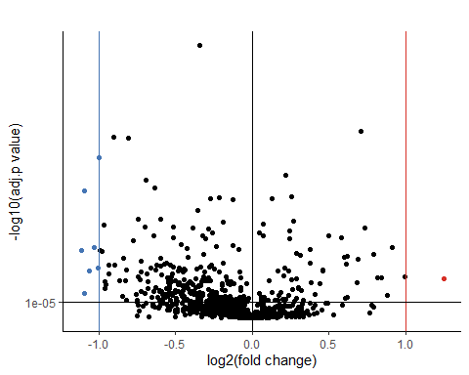

## HCA plot

base1 <- ds   
mtrx1 <- ds[,-1]   
grp1 <- as.character(base1[,1])   
  
k <- length(unique(grp1))   
Cols = function(vec, ord){  
 cols = pal_jco(palette = c("default"), alpha = 1)(length(unique(vec)))  
 return(cols[as.fumeric(vec)[ord]])}  
mtrx1_1 <- mtrx1  
rownames(mtrx1_1) = make.names(grp1, unique=TRUE)  
res.dist1 <- dist(mtrx1_1, method = "manhattan")   
res.hc1 <- hclust(d = res.dist1, method = "ward.D2")   
  
b <- fviz_dend(res.hc1, k = k,   
 cex = 0.55,   
 k_colors = unique(Cols(grp1,res.hc1$order)),   
 color_labels_by_k = F,   
 label_cols = Cols(grp1,res.hc1$order),  
 rect = T,   
 rect_fill = T,  
 horiz = F,  
 lwd = 0.7,   
 show_labels = T,  
 main = "",  
 ylab = "")  
b

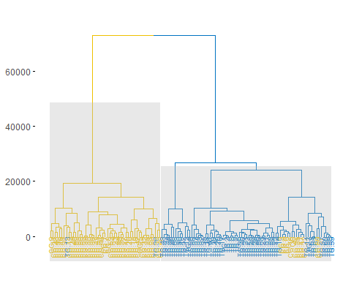

## PCA plot

base1 <- ds   
mtrx1 <- ds[,-1]   
grp1 <- as.character(base1[,1])   
palette_pca <- "lancet"  
  
pca.ds1 <- PCA(mtrx1, scale.unit = T, graph = F)  
a <- fviz_pca_ind(pca.ds1,  
 title = "",  
 geom.ind = "point",   
 col.ind = grp1,   
 palette = palette_pca,   
 addEllipses = T,   
 legend.title = "Groups")  
a

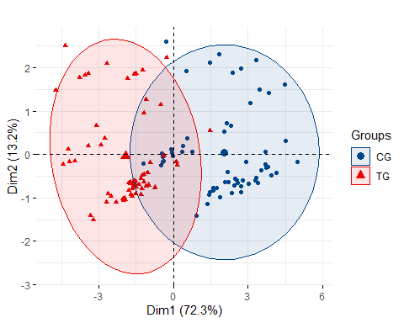

## ROC curve

# start parallel processing  
fc <- as.numeric(detectCores(logical = F))  
cl <- makePSOCKcluster(fc+1)  
registerDoParallel(cl)  
  
# cross-validation  
set.seed(1234)   
trainIndex <- createDataPartition(ds$Label, p = 0.8, list = F, times = 1)  
dsTrain <- ds[ trainIndex,]  
dsValid <- ds[-trainIndex,]  
trainControl <- trainControl(method="repeatedcv", number=10, repeats=10, classProbs = F)   
metric <- "Accuracy"   
  
# machine learning  
set.seed(1234)  
fit.cl <- train(Label~., data=dsTrain, method="svmRadial", metric=metric, trControl=trainControl, tuneLength = 10)  
predicted.classes <- predict(fit.cl, newdata=dsValid)  
  
# ROC curve  
res.roc <- roc(as.numeric(as.factor(predicted.classes)), as.numeric(dsValid$Label))

## Setting levels: control = 1, case = 2

## Setting direction: controls < cases

auroc <- round(as.numeric(auc(res.roc)),2)  
grob <- grobTree(textGrob(paste0("AUC = ", auroc), x=0.25, y=0.75, hjust=0,  
 gp=gpar(col="firebrick2", fontsize=15, fontface=11)))  
c <- ggroc(res.roc, alpha = 0.5, colour = "blue1", linetype = 1, size = 1.5) +theme_bw() + ggtitle("") +   
 geom_segment(aes(x = 1, xend = 0, y = 0, yend = 1), color="black", linetype="dashed") + annotation_custom(grob)  
c

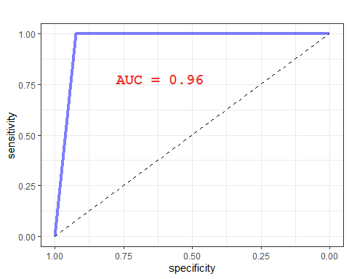

## bootstrap histogram

# start parallel processing  
fc <- as.numeric(detectCores(logical = F))  
cl <- makePSOCKcluster(fc+1)  
registerDoParallel(cl)  
  
# bootstrap  
set.seed(1234)  
trainControl <-trainControl(method="boot", number=1000)  
metric <- "Accuracy"   
  
# machine learning  
set.seed(1234)  
fit.cl <- train(Label~., data=ds, method="svmRadial", metric=metric, trControl=trainControl)  
results <- resamples(list(svm=fit.cl, svm1=fit.cl), trControl = trainControl, metric=metric)  
  
# histogram  
d <-ggplot(results$values, aes(x=results$values[,2])) +   
 geom_histogram(colour="blue", fill="white") + theme_bw() + xlab("Accuracy") + ylab("Frequency")  
d

## `stat_bin()` using `bins = 30`. Pick better value with `binwidth`.

